**The Holy Sacrament of Confirmation Packet**

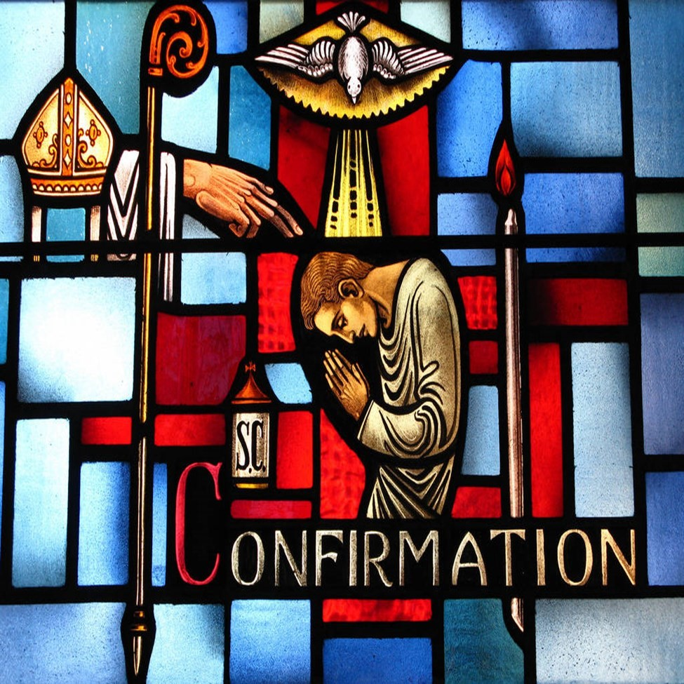

***"He has put His seal on us and given us His Spirit in our hearts as a guarantee."***

***(2 Corinthians 1:22)***

**St. Therese Parish**

Dear Parents and Confirmation Candidates,

Welcome to Confirmation Year!

The Sacrament of Confirmation is one of three of the Sacraments of initiation into the Catholic Church, building on what was begun at Baptism and nourished in the Holy Eucharist. At Confirmation, each candidate will renew those baptismal promises. Confirmation "confirms", strengthens, and perfects baptismal grace and gives us the grace to defend the faith with boldness and courage. The laying on of hands is recognized as the origin of the sacrament and as a continuation of the grace imparted at Pentecost. Confirmation imprints an indelible character on the Christian's soul.

We are delighted that you and your child will be part of our program this year and we look forward to working with you to make this year a meaningful one.

We understand that you and your family have many work, school and social commitments. This is a sacramental preparation program which enables eligibility to receive the sacrament of Confirmation and attendance is not optional. We encourage you and your child to have a conversation regarding the commitment and potential sacrifices which you will need to make to accomplish this.

Hopefully we can enthusiastically rejoice in seeing your children grow in the commitment to their Catholic faith during this Confirmation process. While the team here is committed and ready to make this happen for your child, you and your family remain the principle role models for the candidates and your active participation in that role is essential. Regularly attending Mass each week and receiving the sacraments are things that are essential to help the candidate understand the importance of this sacrament.

This is also a year for the candidates to look outside of themselves and participate in many different types of service. This would include service at home, in the school and town and at St. Therese Parish donating their time to perform community service.

Thank you for your time and interest in this important stage of your child’s spiritual development. Please know of the parish and my prayers for your family and for your child. Sincerely yours in Christ,



Rev. Glenn Kohrman

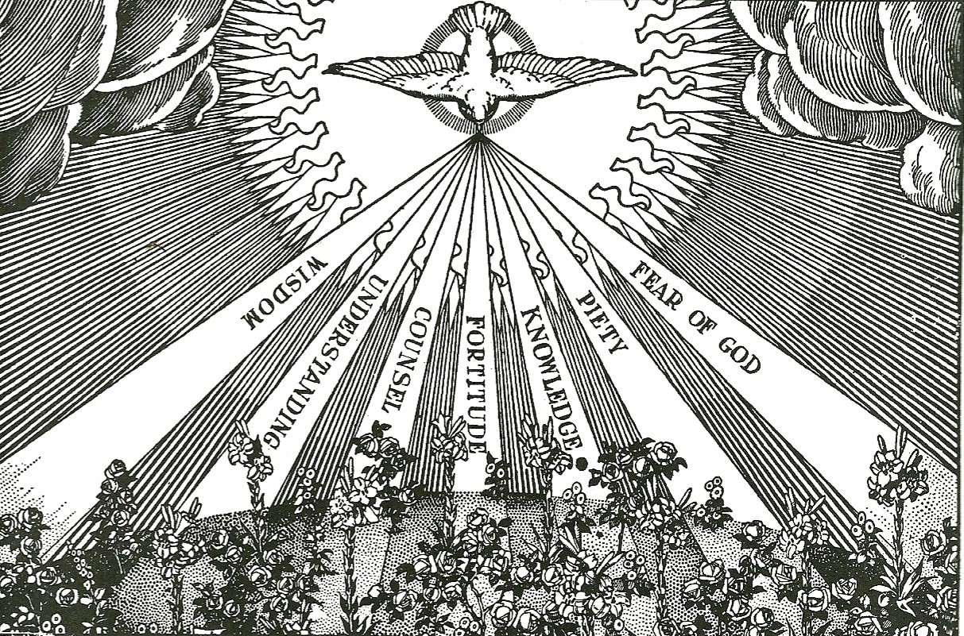

# PREPARATION CHECKLIST

|  |  |  |  |
| --- | --- | --- | --- |
| Item |  | Due Date for Class | |
| □ Punctual Mass attendance for Sunday Obligation |  |  | Every week |
| □ Punctual Class Attendance with Books and Pen(cil) |  |  | Every week |
| □ Copy of Baptism Certificate (even if baptized here)1 |  |  | ASAP* |
| □ Confirmation Preparation Entrance Questionnaire |  |  | ASAP* |
| □ Confirmation Sponsor Certificate (p. 9) |  |  | ASAP* |
| □ Apostolic Project Proposal (p. 16) |  |  | November 24, 2024 |
| □ Read The Holy Gospel of St. Matthew |  |  | December 1, 2024 |
| □ Read The Holy Gospel of St. Mark |  |  | December 8, 2024 |
| □ Read The Holy Gospel of St. Luke |  |  | December 15, 2024 |
| □ Read The Holy Gospel of St. John |  |  | December 22, 2024 |
| □ Read the Acts of the Apostles |  |  | January 12, 2025 |
| □ Historical Report (p. 11-12) |  |  | January 19, 2025 |
| □ Gospel Report on one Gospel (p. 13 ) |  |  | January 26, 2025 |
| □ Patron Saint Report (p. 10) |  |  | February 2, 2025 |
| □ Bishop Letter (Draft) (p. 20) |  |  | February 9, 2025 |

□ Bishop Letter (Final – if draft needs to be redone for grammar errors) March 28, 2021

□ Apostolic Project Summary (p. 17-18) February 16, 2025

□ Final Individual Interview (p. 19, All paperwork & assignments due) February 23,2025

□ Retreat—with sacramental reconciliation TBD

□ Confirmation Rehearsal To be determined

□ Confirmation Mass March 15, 2025 10 am

(At St. John the Baptist)

□ Mass - recognition at 4:30 pm or 8 am or 10:30 am at St. Therese March 16-17th

□ Go make disciples of all nations! From now on…

* ASAP = As soon as possible 1 Please contact the church office or Director of Religious Education for further information. 2 Or Sooner.

**Confirmation Preparation Entrance Questionnaire**

**YES MEANS “I AGREE.” NO MEANS “I NEED HELP UNDERSTANDING OR DOING THIS.” Name: ____________________________________________________Date: ___________________**

## KNOWING THE FAITH

1. I believe in one God. God created all things out of nothing.
2. I believe that there is one God in three Divine Persons: God the Father, God the Son, and God the Holy Spirit.
3. I believe that Jesus Christ is God made man, that He was conceived by the power of the Holy Spirit and born of the Virgin Mary.
4. I believe that Jesus suffered and died on the cross for me, so that my sins could be forgiven and so that I could be with Him in Heaven.
5. I believe that Jesus rose from the dead, thus proving that He truly is God, having power over death.
6. I believe that Jesus instituted (or founded) the Catholic Church, making Peter the first Pope.
7. I believe the truths that God revealed to us through Jesus and that have been handed down to us [to today] through the Apostles and their successors, the Bishops.
8. I believe that the Bible is the Word of God, inspired by the Holy Spirit and written down by human authors.
9. I believe that God is the true author of the Bible, and therefore it contains no error.
10. I believe that the seven sacraments are sacred signs instituted by Christ that give us Grace.
11. I believe that the Holy Eucharist is Jesus truly present Body, Blood, Soul, and Divinity.
12. I believe that the Holy Sacrifice of the Mass makes present to us the suffering, death, and resurrection of Jesus Christ.
13. I believe that the Virgin Mary was conceived without sin and was assumed into heaven body and soul.

## LIVING THE FAITH

1. I choose to follow Jesus, to reject evil, and to keep the Commandments.
2. I plan to go to Mass every Sunday and Holy day of obligation.
3. I plan to pray every day.
4. I plan to go to confession regularly (at least once a month).
5. I plan to receive Jesus in Holy Communion regularly (in a worthy manner, with a clean soul).
6. I plan to fast before receiving Holy Communion for at least one hour.
7. I plan to continue learning about my Faith and to share it with others by my words and example.
8. I want to receive the sacrament of Confirmation.

**Good Daily Habits to Grow in Holiness**

Daily Spiritual Activities – (Start with two or three and build up)

|  |  |  |  |  |  |  |  |
| --- | --- | --- | --- | --- | --- | --- | --- |
| Prayer or Activity | Sunday | Monday | Tuesday | Wednesday | Thursday | Friday | Saturday |
| Morning Offering |  |  |  |  |  |  |  |
| Guardian Angel |  |  |  |  |  |  |  |
| Mass | Required |  |  |  |  |  |  |
| Rosary/Divine Mercy Chaplet |  |  |  |  |  |  |  |
| Mental Prayer – meditation or “talking with God (5-10  Minutes) |  |  |  |  |  |  |  |
| Visit to the Blessed Sacrament |  |  |  |  |  |  |  |
| Quick Short Prayers |  |  |  |  |  |  |  |
| Bible reading (5-10 minutes) |  |  |  |  |  |  |  |
| Examination of Conscience |  |  |  |  |  |  |  |
| Act of Contrition |  |  |  |  |  |  |  |

“I BELIEVE IN ONE, HOLY, CATHOLIC AND APOSTOLIC CHURCH”

*CCC 811* “This is the sole Church of Christ, which in the Creed we profess to be one, holy, catholic and apostolic” (*Second Vatican Council, Lumen Gentium 8*). These four characteristics, inseparably linked with each other, (*DS 2888*) indicate essential features of the Church and her mission. The Church does not possess them of herself; it is Christ who, through the Holy Spirit, makes his Church one, holy, catholic, and apostolic, and it is he who calls her to realize each of these qualities.

*CCC 812* Only faith can recognize that the Church possesses these properties from her divine source. But their historical manifestations are signs that also speak clearly to human reason. As the First Vatican Council noted, the “Church herself, with her marvelous propagation, eminent holiness, and inexhaustible fruitfulness in everything good, her catholic unity and invincible stability, is a great and perpetual motive of credibility and an irrefutable witness of her divine mission” (*First Vatican Council, Dei Filius 3: DS 3013*).

|  |  |
| --- | --- |
| **ONE**    *CCC 816*. “The sole Church of Christ is that which our Savior, after his Resurrection, entrusted to Peter’s pastoral care, commissioning him and the other apostles to extend and rule it.” Second Vatican Council, Lumen Gentium, 8 § 2. | **HOLY**    *CCC 823*. “The Church . . . is held, as a matter of faith, to be unfailingly holy. This is because Christ, the Son of God, who with the Father and the Spirit is hailed as ‘alone holy,’ loved the Church as his Bride, giving himself up for her so as to sanctify her; he joined her to himself as his body and endowed her with the gift of the Holy Spirit for the glory of  God… and her members are called “saints”.” |
| **CATHOLIC**    *CCC830.* The word “catholic” means  “universal,” in the sense of “according to the totality” or “in keeping with the whole.” The Church is catholic in a double sense: First, the Church is catholic because Christ is present in her. “Where there is Christ Jesus, there is the Catholic Church” *Saint Ignatius of Antioch, Ad Smyrn. 8,2: Apostolic Fathers, II/2,311…*    *CCC 831*. Secondly, the Church is catholic because she has been sent out by Christ on a mission to the whole of the human race… | **APOSTOLIC**    *CCC 857*. The Church is apostolic because she is founded on the apostles, in three ways: - she was and remains built on “the foundation of the Apostles”, the witnesses chosen and sent on mission by Christ himself;   * with the help of the Spirit dwelling in her, the Church keeps and hands on the teaching the “good deposit,” the salutary words she has heard from the apostles; * she continues to be taught, sanctified, and guided by the apostles until Christ’s return, through their successors in pastoral office: the college of bishops, assisted by priests, in union with the successor of Peter, the Church’s supreme pastor. |

**WHAT IS THE ROLE OF THE CONFIRMATION SPONSOR?**

Candidates for Confirmation, as for Baptism, fittingly seek the spiritual help of a sponsor. To emphasize the unity of the two sacraments, it is appropriate that this be one of the baptismal godparents. Although one of the Confirmation candidate’s godparents is the ideal, this is not the only choice (CCC 1311).

Like the godparents chosen at Baptism, sponsors “must be firm believers, able and ready to help (the Confirmed) on the road of Christian life. Their task is a truly ecclesial function….bearing some responsibility for the development and safeguarding of the grace given at Baptism” (CCC 1255). Like parents and godparents, they share in the responsibility for the salvation of the young soul entrusted to them.

Because our life on earth is “a pilgrimage to the Father which takes place primarily in the heart” (St. Pope John Paul II, *The Trinity’s Embrace*), the sponsor should be a Catholic who loves and lives his or her faith and continues to grow in the knowledge of the Catholic faith. This is evident in a person who spends time in daily prayer and frequent encounters with Jesus in the Sacraments of Penance and Holy Eucharist. Consequently, the sponsor’s heart reflects the tender and affectionate love of the hearts of Jesus and Mary and the gifts of the Holy Spirit, providing a living example of joyful Christian life.

In order to accept this responsibility, your Confirmation sponsor needs:

· to be at least 16 years of age.

· to have received the Sacraments of Baptism, Eucharist and Confirmation in the Catholic Church.

· not to have married outside the Catholic Church or is currently cohabitating, i.e. “living in sin”.

· to attend Mass regularly on Sundays and Holy Days of Obligation and receive the Sacraments of the Holy Eucharist and Penance regularly.

· to be someone other than your parent. (Code of Canon law 874 §1)

Your sponsor needs to understand and accept the responsibility which is undertaken as a Sponsor, promise to be a support and example that reflects the spirit and teaching of the Roman Catholic Church, and be prepared to assist you with support, encouragement and prayer. If your sponsor is a teenager, e.g., your sibling, he should be actively involved in the parish: 1) Involved in the teen group/attending religion classes, 2) Making a weekly Holy Hour if possible 3) Dating responsibility [being chaste] and 4) Aspires to get to heaven, e.g., be in a state of grace

**WHOM SHOULD I CHOOSE FOR MY CONFIRMATION SPONSOR?**

SOMEONE WHO WILL DEDICATE THEMSELVES TO HELPING YOU GET TO HEAVEN WHILE BRINGING AS MANY OTHERS WITH YOU AS YOU CAN.

St. Therese Catholic Church

### Godparent/Sponsor Eligibility

I have been asked to be a godparent/sponsor in accordance with Can. 874: *to be permitted to take on the function of sponsor a person must: be designated by the one to be baptized, by the parents or the person who takes their place, or in their absence by the Pastor or minister and have the aptitude and intentions of fulfilling this function; have completed the sixteenth year of age, unless the diocesan Bishop has established another age, or the Pastor or minister has granted an exception for a just cause; be a Catholic who has been confirmed and has already received the most holy sacrament of the Eucharist and who leads a life of faith in keeping with the function to be taken on; not to be bound by any canonical penalty legitimately imposed or declared; not be the father or mother of the one to be baptized.*

I ____________________________am a registered member of ________________________ Parish in ______________________________ (city, state). I have been asked to stand as godparent/sponsor for _____________________________ as s/he receives the sacrament of (please circle) Baptism/Confirmation.

In accepting this responsibility, I affirm that (please check each that applies):

______ 1. I have received the sacraments of initiation. (Baptism, Eucharist, and Confirmation.) ______ 2. I am at least 16 years of age.

______ 3. I participate regularly in Sunday Mass and give witness to my faith by receiving Holy Communion.

______ 4. I believe all that the Catholic Church professes and teaches, and I truly make an effort to incorporate these teachings into my daily life.

______ 5. I am aware that I am assuming responsibility to be a good role model for the person I am sponsoring by my life of prayer and by my Catholic example.

______ 6. *If married*: I am validly married according to the laws of the Catholic Church. I was married by a priest or deacon; married by a minister with proper dispensation; or had my marriage validated by the Catholic Church.

*If single*: I am living a Christian life in accordance with the laws of God and the Catholic Church.

______ 7. I am not the mother or father of the one to be baptized.

Signature of Godparent/Sponsor __________________________________ Date: ___________ Pastor/Administrator’s Acknowledgment:

As Pastor, I verify that the above name-person is a registered member of the above named parish.

Pastor/Administrator Signature: ___________________________________ Date: ___________

SEAL

Please complete and return to the parish office.

## CHOOSING A PATRON SAINT

**WHO ARE THE SAINTS?**

A name given in the New Testament to Christians generally (Colossians 1:2) but early restricted to persons who were eminent for holiness. In the strict sense, saints are those who distinguish themselves by heroic virtue during life and whom the Church honors as saints either by her ordinary universal teaching authority or by a solemn definition called canonization. The Church’s official recognition of sanctity implies that the persons are now in heavenly glory, that they may be publicly invoked everywhere, and that their virtues during life or martyr’s death are a witness and example to the Christian faithful - Fr. John Hardon, *Pocket Catholic Dictionary*

**HOW DO I CHOOSE A SAINT?**

A patron saint is chosen by each person preparing for Confirmation. Begin by reading good biographies of saints, not just short descriptions of them. There are many good movies that faithfully depict the lives of the saints. [A good website to learn of saints and their attributes: [http://saints.sqpn.com/]](http://saints.sqpn.com)

After doing this you should select one saint or blessed whose spirituality or example you would like to follow knowing:

That saint will become a particular friend on life’s journey to Heaven.

You may ask special intercessions from your patron in pray.

You should honor your patron saint by attending Mass on his feast day.

You may choose a patron who is either a declared Saint or Blessed.

Some choose two saints and take both names at Confirmation.

You can even add that saint’s name to your own name (e.g. Darryl James Peter Adams).

The patron saint provides a model of charity; we are assured of his intercession. *CCC 2156*

The name one receives is a name for eternity. In the kingdom, the mysterious and unique character of each person marked with God’s name will shine forth in splendor. “To him who conquers... I will give a white stone, with a new name written on the stone which no one knows except him who receives it” (Rev 2,17). “Then I looked, and lo, on Mount Zion stood the Lamb, and with him a hundred and forty-four thousand who had his name and his Father’s name written on their foreheads” (Rev 14,1). *CCC 2159*

On Confirmation day, the Bishop will address you individually according to your saint’s name (e.g. “John Bosco, be sealed with the gift of the Holy Spirit”). It is important to put a lot of thought into this choice! Better yet, ask Our Lord Jesus Christ which saint He would like you to imitate in order to accomplish with Jesus the special task God has planned for you in history.

## PATRON SAINT REPORT

Name: __________________________________________________ Date: ________________

The following information must be included:

1. Biographical information on the saint
   1. Name (original name if now known by a title or other version)
   2. Dates and places of birth and death
   3. Description of the saint’s service to God and others
   4. Feast day
   5. Symbol (if any) associated with the saint
   6. Circumstances of death
   7. If the saint is a patron of any group (e.g., group of martyrs), discuss the reason and significance
   8. Discuss any specific devotion(s) that were attributed to this saint

1. Why did the Church canonize this person?

1. Personal influence of the saint on your life, including: A. Why did you choose this saint?
   1. What virtues and qualities did this saint have that you wish to imitate in your life?
   2. How are you going to honor this saint for the rest of your life?

**You will probably be asked to tell a little bit about your saint in class, so be prepared!**

**Please turn in the saint report on a separate sheet(s) of paper. 12 Font double spaced typed. Times New Roman.**

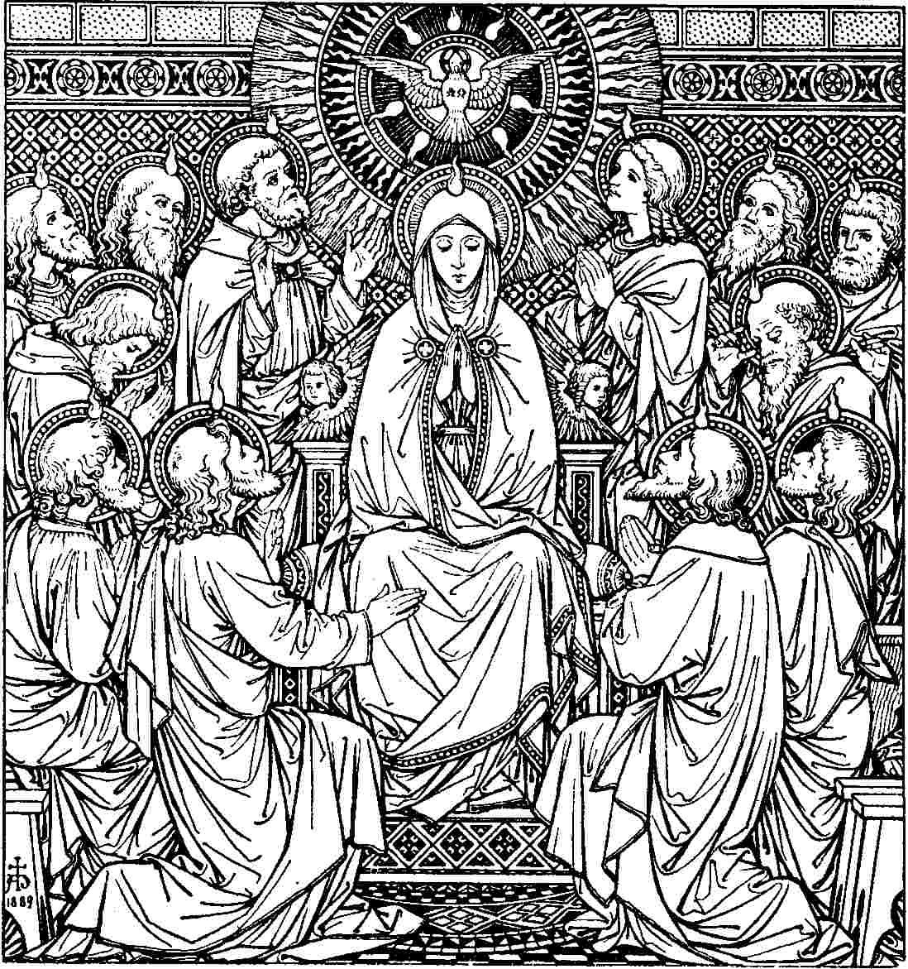

## Historical Report

**Background**: Knowing our Lord Jesus Christ founded the Church almost 2000 years ago, confirmed Catholics need to understand that knowing the faith is more than just memorizing prayers and believing the Sacraments and Commandments (as important as that is). Millions of Catholics have lived before us and worked and fought valiantly to defend and explain our faith to the world at large. The questions below will help prepare you for Confirmation by exposing you to the breadth of the Church’s history.

**Please turn in the historical report on a separate sheet(s) of paper.**

Pick two question/topics below (this page and next) and write a few sentences to answer the questions posed on each topic.

1. Choose one Pope from this list: (Leo XIV, St. Pius X, Benedict XV, Pius XI, Pius XII, St. John XXIII, St.

Paul VI, John Paul I, St. John Paul II, Benedict XVI, Francis)

* 1. Give a brief biographical summary of his life and when he reigned as Pope?
  2. Name at least one major historical event that happened during his reign?
  3. Name at least one of encyclicals and what it briefly addressed
  4. How is this Pope best remembered?

1. Choose one of these heresies: (Arianism, Docetism, Monothelitism, Nestorianism, or Jansenism) a. When did it occur?
   1. What does it mean?
   2. Why is it wrong?
2. Protestantism
   1. What is Protestantism?
   2. Define the essential errors of Protestantism: Sola Scriptura, Sola Fide and Priesthood of all Believers
   3. What does “justification by faith alone” mean?
   4. Give some reasons why Protestants do not celebrate the Mass? (More on next page)
3. Briefly describe one of the following Protestant denominations: (Baptists, Methodists, Episcopalians

[Anglicanism], Lutheran or Brethren [Amish or Mennonite])

* 1. Describe this denomination and how it broke away from the Catholic Church?
  2. Who was the leader who broke away?
  3. Why is it not the Church started by Christ?

1. Define the heresy of Modernism
   1. Define the heresy of Modernism.
   2. How is this affecting the Church?
   3. Who spoke against it?
   4. Is it still a problem? Why or why not?
2. Choose a saint/martyr who lived or died in America:

(http://en.wikipedia.org/wiki/List_of_American_saints_and_beatified_people)

* 1. Where was he or she from?
  2. Why did he come to America if not born here?
  3. How did he die?
  4. Do you think Catholics in America will ever be called to die for their faith?

1. What was the Vatican II council?
   1. What is an ecumenical council?
   2. How many councils have there been?
   3. When did Vatican II occur?
   4. What is significant about this council?
2. Choose one of the Church Fathers and answer the following questions (St. Justin Martyr, St.

Polycarp, St. Augustine, St. Ambrose, St. Irenaeus, St. Ignatius or St. Cyril of Jerusalem)

* 1. Describe what is meant by the phase “Father of the Church”
  2. Give a short summary of his life of the Father you picked
  3. What famous work(s) is he known for?
  4. Describe one work and how it relates to Catholic dogma.

1. Describe the relationship between Sacred Tradition and Sacred Scripture
   1. What is Sacred Tradition?
   2. What is Sacred Scripture?
   3. How are our Catholic beliefs tied to both?

Good sources for help in answering the questions:

Ask a Catholic - AskACatholic.com

Catholic Culture – www.catholicculture.org

Catholic Answers – www.catholic.com

Saints - http://saints.sqpn.com/

Catholic Encyclopedia - www.newadvent.org/cathen/

Papal encyclicals - [www.papalencyclicals.net/](http://www.papalencyclicals.net/)

## Gospel Report (for one Gospel only)

**Name: ___________________________________ Gospel:__________________**

1. Why did I choose this Gospel to report on?

1. What event in Christ’s life most impressed you and why?

1. What miracle that Christ performed most impressed you and why?

1. Give a brief timeline of Christ’s passion. For example: Holy Thursday – Last Supper in the early evening Holy Thursday – Agony in Garden occurred in the late evening, etc. (Please include all Good Friday events and timeline)

1. Name two differences between any two of the Gospels.

1. How is the Acts of the Apostles different from the Gospels?

1. How did the Holy Spirit change the Apostles?

1. Why should you read the Bible (especially the N.T.) on a regular basis?

# APOSTOLIC PROJECT

The “APOSTOLIC PROJECT” takes the place of the traditional “service hours.” It will be designed by the students and approved by both parents and the teacher. Please do not begin the project until it has been ap-

proved. The project will require fifteen (15) hours of work/service/prayer. It must incorporate at least one of the Spiritual Works of Mercy (listed below) and include a minimum five (5) hours of Spiritual Work.

**THE GOAL IS THE SALVATION OF OTHER SOULS!**

(YOU WANT THEM TO KNOW GOD’S LOVE SO THAT THEY MIGHT RECEIVE HIS GRACE AND DO HIS WILL.)

**THE CORPORAL AND SPIRITUAL WORKS OF MERCY**

“The works of mercy are charitable actions by which we come to the aid of our neighbor’s spiritual and bodily necessities. Giving alms to the poor is one of the chief witnesses to fraternal charity; it is also a work of justice pleasing to God.” *CCC 2447*

14 What does it profit, my brethren, if a man says he has faith but has not works? Can his faith save him? 15 If a brother or sister is ill-clad and in lack of daily food, 16 and one of you says to them, “Go in peace, be warmed and filled,” without giving them the things needed for the body, what does it profit? 17 So faith by itself, if it has no works, is dead. 18 But some one will say, “You have faith and I have works.” Show me your faith apart from your works, and I by my works will show you my faith. James 2:14-18 cf. 1John 3:17

## CORPORAL SPIRITUAL

FEEDING THE HUNGRY COUNSELING THE DOUBTFUL.

GIVING DRINK TO THE THIRSTY INSTRUCTING THE IGNORANT

CLOTHING THE NAKED ADMONISHING SINNERS

SHELTERING THE HOMELESS COMFORTING THE AFFLICTED

VISITING THE SICK FORGIVING OFFENSES

VISITING THE IMPRISONED BEARING WRONGS PATIENTLY

BURYING THE DEAD PRAYING FOR THE LIVING & THE DEAD

“Go therefore and make disciples of all nations, baptizing them in the name of the Father and of he Son and of the Holy Spirit, teaching them to observe all that I have commanded you.” *Matthew 28:19-20*

## SOME SUGGESTIONS FOR YOUR APOSTOLIC PROJECT

· Join the Legion of Mary and participate on a weekly basis.

· Go to the Thursday night or Saturday morning Holy Hour. Go and offer for it for someone who will die that day, and that God will give then the grace of dying in a state of grace.

· Make 15 Holy Hours, Thursday night or Saturday morning deciding in advance who to pray for during that hour. Hours need to be documented, i.e., make a list in advance of the project of people, families, souls in purgatory, Confirmation candidates, priests, etc. · Volunteer with the weekly soup kitchen and then pray for an hour in Church for those eating at the soup kitchen.

· Visit many or all cemeteries where family members are buried and pray the Rosary for the repose of each soul, i.e., one complete Rosary for each individual

· Make a video recording of great religious speeches (E.G. St. Peter at Pentecost, St.

Stephen, St. Thomas Moore at his trial, etc.)

· Make a family tree and pray a rosary for each member of your extended family; that would mean at least forty-five (45) different people.

· Teach and prepare a younger sibling for First Holy Communion (document lesson plans, class notes, area of study, Participation at Mass etc. for 30-45+ minutes a week) · Create religious videos for the Internet describing some aspect of the Catholic Faith.

## CREATIVE WAYS OF COMBINING PRAYER AND GOOD WORKS

· Visit a nursing home once or twice weekly, talk with one or more lonely patients, may be even write them letters.

· Mom lawns for an elderly neighbor and pray Rosary daily or weekly for them.

· Bring someone to Mass each wee who cannot get there alone.

· Help someone study for school / and or teach them to pray the Rosary.

· Teach/Prepare a younger Sibling for First Holy Communion. Prepare lessons and teach 30-45 minutes per week.

· Teach a sibling how to read using the Gospels.

· Teach a Sibling How to say the Rosary while offering up Intentions for your Family

## HERE’S A TIMELINE TO HELP YOU STAY ON TRACK

**Before or by Thanksgiving**: Make a plan for the Apostolic Project and review it with your parents and your teacher.

**By Christmas:** Calculate how many more hours you need.

**During Lent and by Easter:** Write up the summary, signed by your parent and turn it in.

# APOSTOLIC PROJECT PROPOSAL

**Name: ____________________________________________________ Date: ______________ Parent/guardian signature: ________________________________**

My Apostolic Project will include the following works of mercy (please check all that apply):

## CORPORAL WORKS OF MERCY

 Feeding the hungry.

 Giving drink to the thirsty.

 Clothing the naked.

 Sheltering the homeless.

 Visiting the sick.

 Visiting the imprisoned.

 Burying the dead.

## SPIRITUAL WORKS OF MERCY

 Counseling the doubtful.

 Instructing the ignorant.  Admonishing sinners.

 Comforting the afflicted  Forgiving offenses.

 Bearing wrongs patiently.

 Praying for the living and the dead.

What specific work(s) do you propose?

__________________________________________________________________________________________________________ __________________________________________________________________________________________________________ When will this work be done?

__________________________________________________________________________________________________________ __________________________________________________________________________________________________________ Where will this work be done?

_________________________________________________________________________________________ _________________________________________________________________________________________ In what way(s) have you done this kind of work before?

_________________________________________________________________________________________ _________________________________________________________________________________________ With whom will you collaborate to finish this work?

_________________________________________________________________________________________ _________________________________________________________________________________________ Who stands to benefit from this work?

_________________________________________________________________________________________ _________________________________________________________________________________________ How will you be closer to God (spiritually) and His Church because of your work?

_________________________________________________________________________________________

_________________________________________________________________________________________

APOSTOLIC PROJECT SUMMARY DUE BEFORE THE FINAL INTERVIEW.

## Name: ______________________________________________________ Date: ___________ Parent/guardian signature: ________________________________

My Apostolic Project included the following works of mercy (please check all that apply):

**CORPORAL WORKS OF MERCY**

 Feeding the hungry.

 Giving drink to the thirsty.

 Clothing the naked.

 Sheltering the homeless.

 Visiting the sick.

 Visiting the imprisoned.

 Burying the dead.

**SPIRITUAL WORKS OF MERCY**

 Counseling the doubtful.

 Instructing the ignorant.

 Admonishing sinners.

 Comforting the afflicted  Forgiving offenses.

 Bearing wrongs patiently.  Praying for the living and the dead.

What specific work(s) did you complete?

_________________________________________________________________________________________

_________________________________________________________________________________________

_________________________________________________________________________________________

_________________________________________________________________________________________

_________________________________________________________________________________________

What was easy or difficult about it?

_________________________________________________________________________________________

_________________________________________________________________________________________

_________________________________________________________________________________________

_________________________________________________________________________________________

_________________________________________________________________________________________

Who benefited from your work?

_________________________________________________________________________________________

_________________________________________________________________________________________

_________________________________________________________________________________________

_________________________________________________________________________________________ How are they now closer to God and His Church because of your work?

_________________________________________________________________________________________ _________________________________________________________________________________________

_________________________________________________________________________________________

_________________________________________________________________________________________

In what ways were they in a position to thank you?

_________________________________________________________________________________________

_________________________________________________________________________________________

_________________________________________________________________________________________

_________________________________________________________________________________________

How are you now closer to God and His Church because of your work?

_________________________________________________________________________________________

_________________________________________________________________________________________

_________________________________________________________________________________________

_________________________________________________________________________________________

_________________________________________________________________________________________

What would be a more challenging work of mercy for you?

_________________________________________________________________________________________

_________________________________________________________________________________________

_________________________________________________________________________________________

_________________________________________________________________________________________

_________________________________________________________________________________________

What works of mercy do you think you could do on a regular basis?

_________________________________________________________________________________________

_________________________________________________________________________________________

_________________________________________________________________________________________

_________________________________________________________________________________________

For which works of mercy is your Confirmation Saint known?

_________________________________________________________________________________________

_________________________________________________________________________________________ _________________________________________________________________________________________ _________________________________________________________________________________________

_________________________________________________________________________________________

What would it take for you to do the same work(s) of mercy?

_________________________________________________________________________________________

_________________________________________________________________________________________

_________________________________________________________________________________________

_________________________________________________________________________________________

# **QUESTIONS FOR THE FINAL INTERVIEW**

The questions will be used for discussion at the Interview. If you have difficulty in answering any questions, please talk with your parents before the interview. This is an opportunity to discern readiness for the Sacrament of Confirmation.

1. Who are the people who pray for you?
2. Which angels and saints are interceding for you?
3. Who are the people who are trying to help you get to heaven?
4. Do you make it a point to help others? In what ways?
5. What have you done for the salvation of someone else?
6. Are you willing to talk to people about Christ, Our Lord?
7. How important is it to you to help people believe in Jesus, belong to His Church, receive the Sacraments & go to heaven? Also:

+ Name three reasons you’re a Catholic

+ Name three reasons you love being Catholic + Name three reasons you love Our Lord Jesus Christ

1. How would you act in the following situations?

**+** You meet a Protestant friend who asks you, “Why are you a Catholic? What difference does it make?”

**+** A friend of yours remarks, “I don’t understand why you can’t just go to your room and tell God that you’re sorry for your sins. Why tell a priest that you’re sorry?”

**+**  Someone says to you that certain Catholic teachings cannot be found in the Bible – for example, Purgatory and the Assumption into heaven of the Blessed Virgin. “How can you believe in these teachings that aren’t in the Bible?”

**+** A friend of yours says that a person should do what feels right. The friend says, “I don’t feel bad if I shoplift, so how can that be wrong?”

**+** A non-Catholic ask, “Why do you have to go to church (Mass) every week? Why is that important”?

1. How do you intend to continue to learn more about Jesus and His Church?
2. Are you prepared to live the teachings of Christ and His Church, i.e. what the Pope and the bishops in union with him teach?
3. How do you intend to be active in the Church after Confirmation?
4. What are the works of the parish that you could do?
5. What is the importance of attending Mass on Sundays and Holy Days of Obligation?
6. What is the importance of frequent reception of the Sacrament of Penance? When must you go to Confession?
7. How have you made prayer more a part of my life?
8. How have you incorporated reading Sacred Scripture into your relationship with God?
9. What is your favorite Gospel story? Why do you like it?
10. When and why were the Apostles hiding in the upper room?
11. What’s the difference between the Resurrection and the Ascension?
12. What were Our Lord’s last instructions to the Apostles before He ascended into heaven?
13. What were the Apostles doing in the upper room before Pentecost?
14. What happened at Pentecost? What did the Apostles start doing after Pentecost?
15. What’s the difference between the Ascension and the Assumption?
16. Is God asking you to be a saint?
17. What are the vocations to which God might be calling you?
18. Why do you want to be confirmed?

# SAMPLE LETTER TO THE BISHOP

[Note: If a different bishop presides at Confirmation, the teacher will supply the Bishop’s name and address.]

To complete this letter, please refer to the pages in your workbook describing the “Apostolic Project.” Please type or write Neatly! Final draft is due before the final interview.

+++++++++++++++++++++++++++++++++++++++++++++++++++++++++++++++++++++

Month Day, Year

Most Rev. Kevin C. Rhoades, D.D. Diocese of Fort Wayne – South Bend

Archbishop Noll Catholic Center

P.O. Box 390

Fort Wayne, IN 46801

Your Excellency:

Praised be Jesus Christ! As a parishioner of St. Therese Parish, the purpose of this letter is to request the Sacrament of Confirmation this Spring when you come to St. John the Baptist on March 15th, 2025.

During this past year, I have studied the Catholic Faith, and it is very important to me because…

The saint that I chose for my patron for Confirmation is Saint… St./Blessed _____ is well known for…

The reasons I chose St. _____ for my patron are…

As a requirement in preparation for Confirmation, I participated in an apostolic project. My project involved...

I wish to be confirmed because…

Thank you, Bishop Rhoades, for…

Please say a prayer for me as I continue preparing for the coming of the Holy Spirit in the Sacrament of Confirmation. I will pray for you and your intentions.

God bless you,

(Signature)

Name (First and Last)